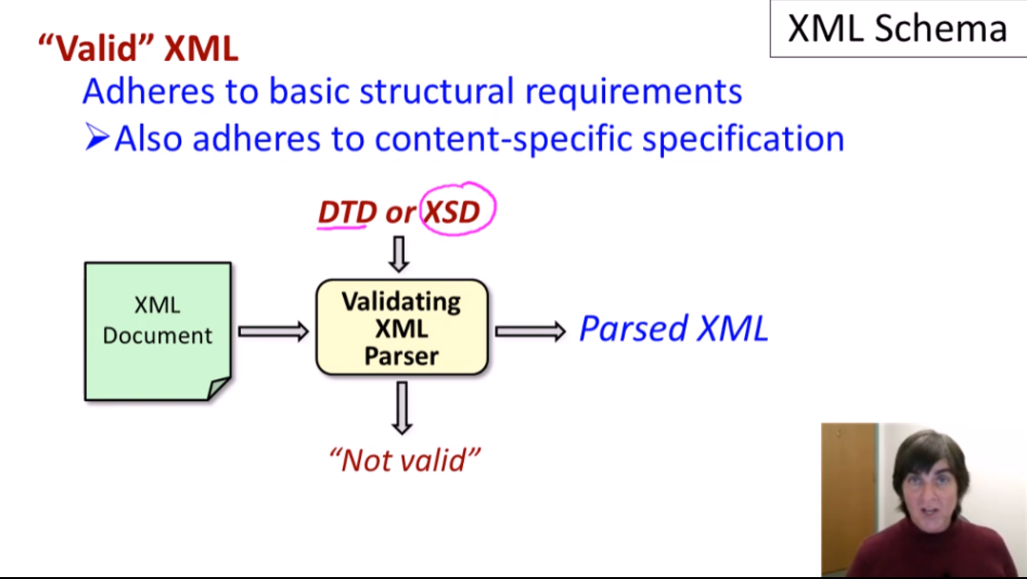

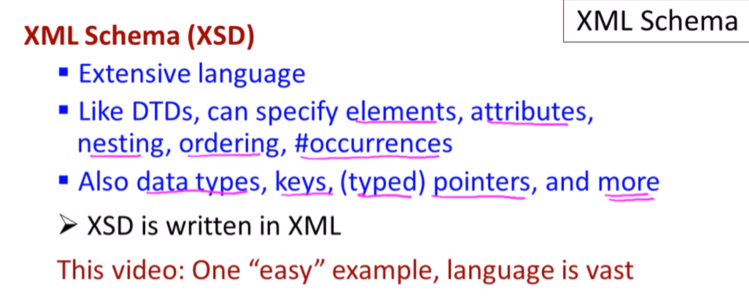

XML Document

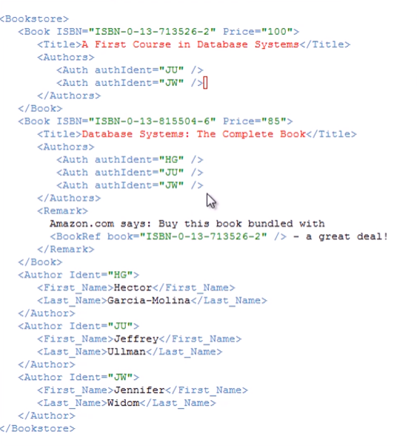

XSD Document

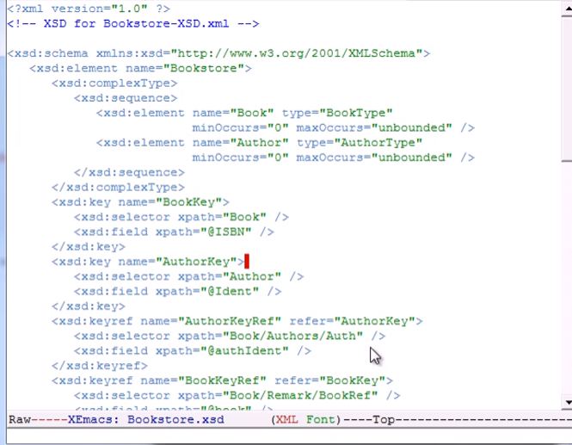

* This is in a separate file
* Both are .xml

Same command for validation

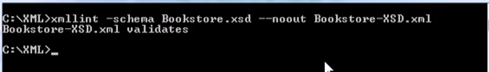

***Examples:***

**Price must be in integer:**

XML

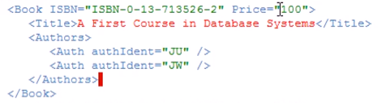

XSD



**Changing the price with a word:**

XML

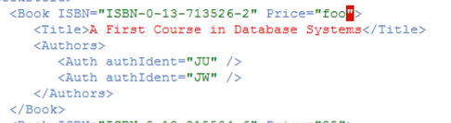

XSD



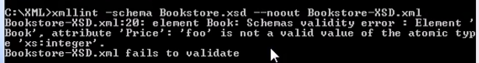

* In DTD, this will be okay because all attributes are treated as strings
* But in XSD, this will fail to validate

**Keys**

* specify that a particular attribute or component must be unique within every element of the same type

XSD Sample

**Changing Key with Existing Key**

XML

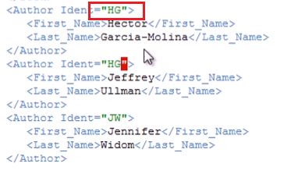

XSD

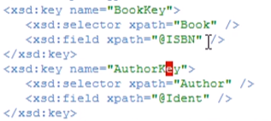

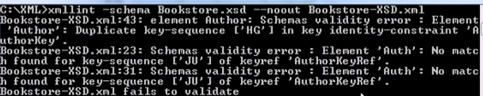

**Changing key of ISBN to a key of Ident**

* In DTD, this will not be valid because the IDs should be GLOBALLY unique
* But in XSD, this will be valid because the key should only be unique within the specified element (ISBN must only be unique within Book, Ident must only be unique within Author)

XML

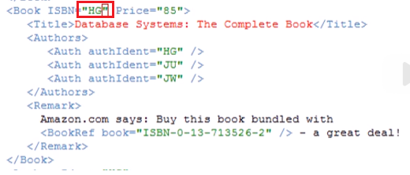

XSD



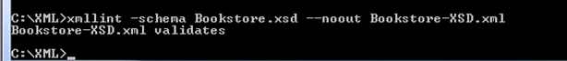

**References**

* Allows us to have typed pointers

XSD

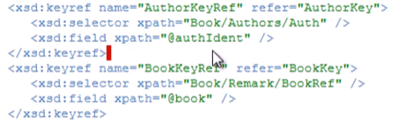

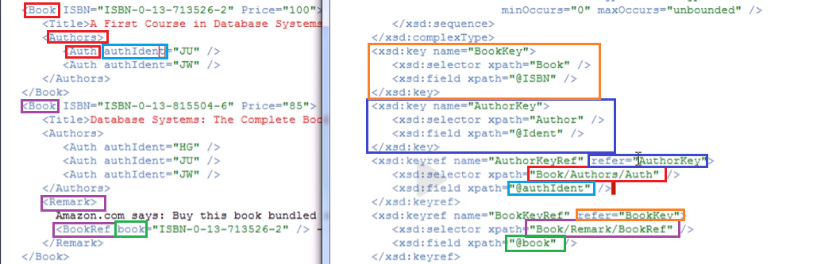

**Changing a reference of authIdent into a non-existing key of Ident:**

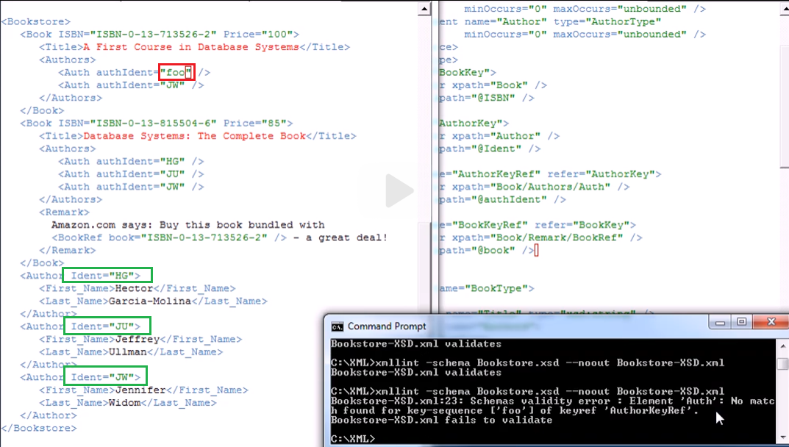

**Changing a reference of authIdent with an identical reference with the next reference:**

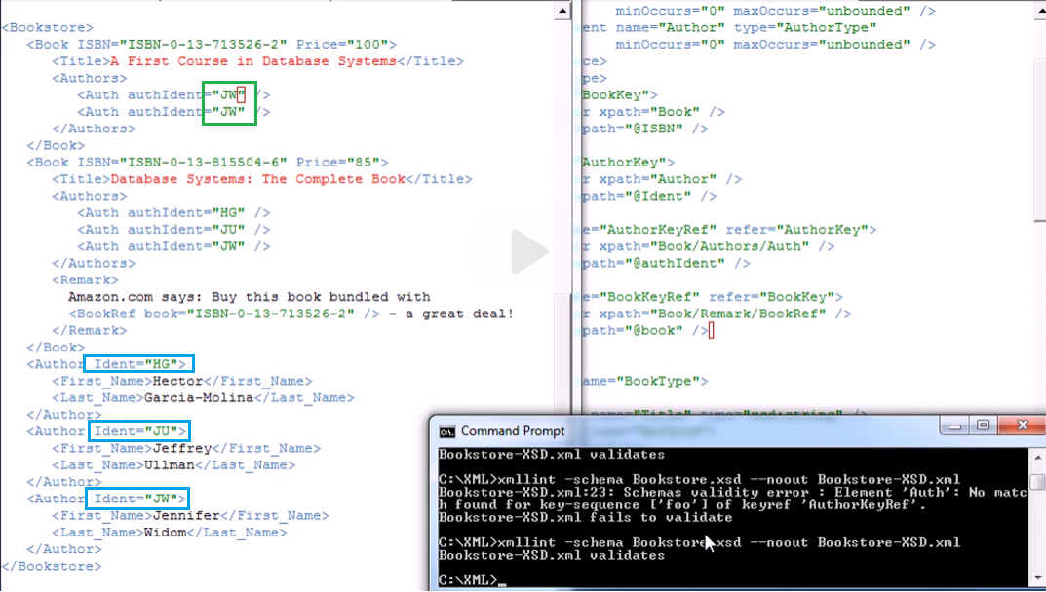

* No problem, just pointing to the same author!

**Changing a reference of book with a key for Ident (author):**

* In DTDs, this will be valid because the keys have no typed pointers (no restrictions on where key to point to)
* In XSDs, this will not be valid because we specified that this pointer or this reference must be to a book element and not to an author element

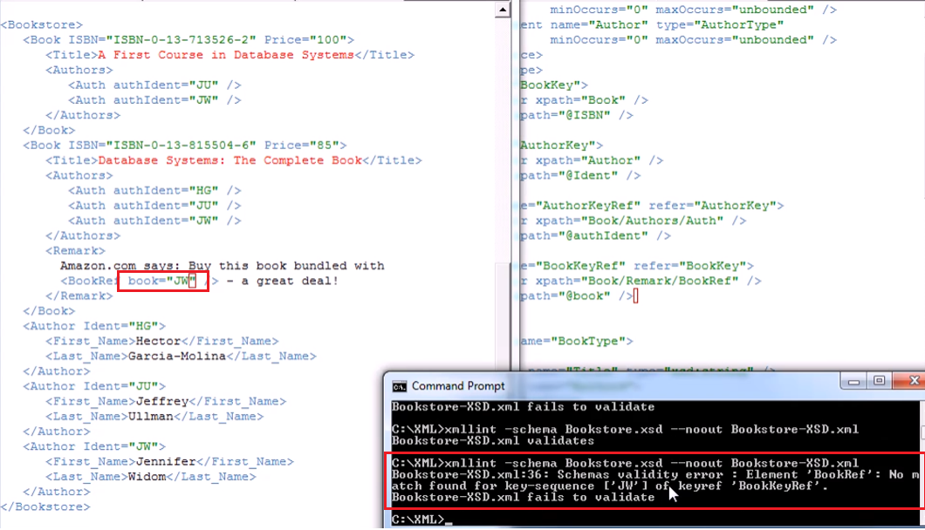

**Specifying Occurrences**:

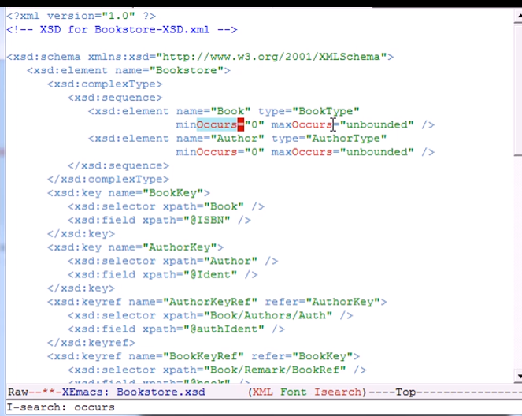

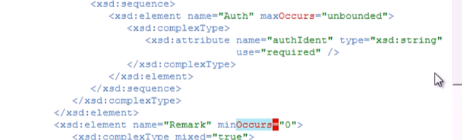

* minOccurs and maxOccurs default is ***1*** (if not specified)
* Maximum flexibility: “unbounded”

**Removing the two Author from the first Book**

XML

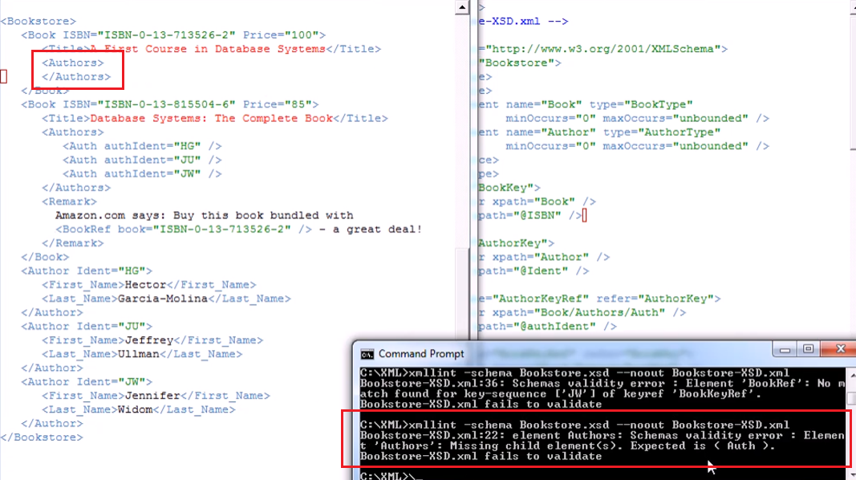

XSD

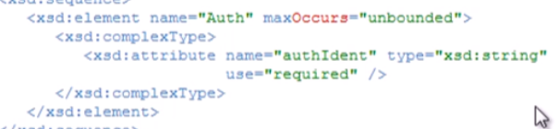

* Auth should have at least 1
* Unspecified minOccurs is defaulted to minOccurs = 1

**Removing the whole Authors Element**

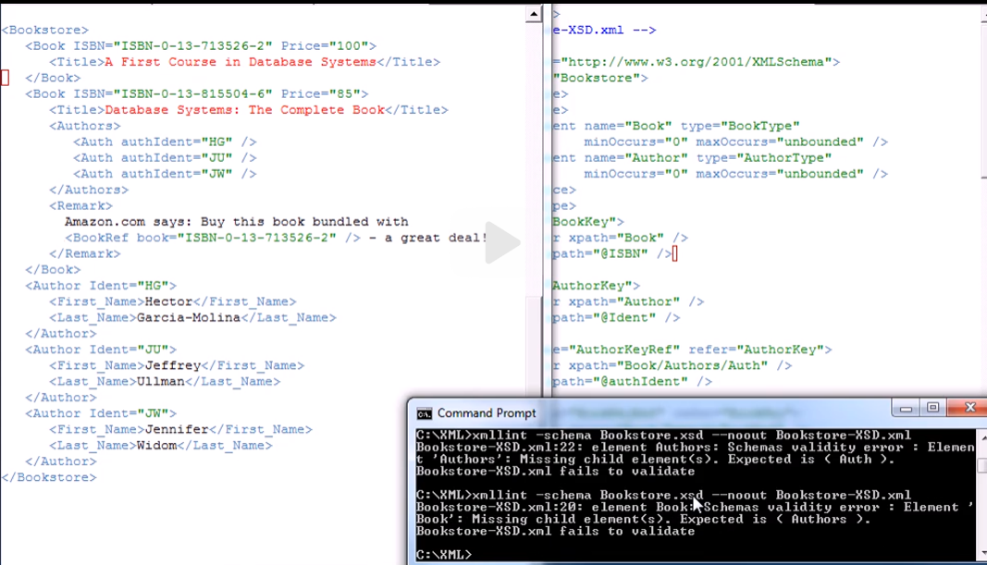

* Book must have Authors element!

**Creating additional Remark (more than 1 remark)**

XML

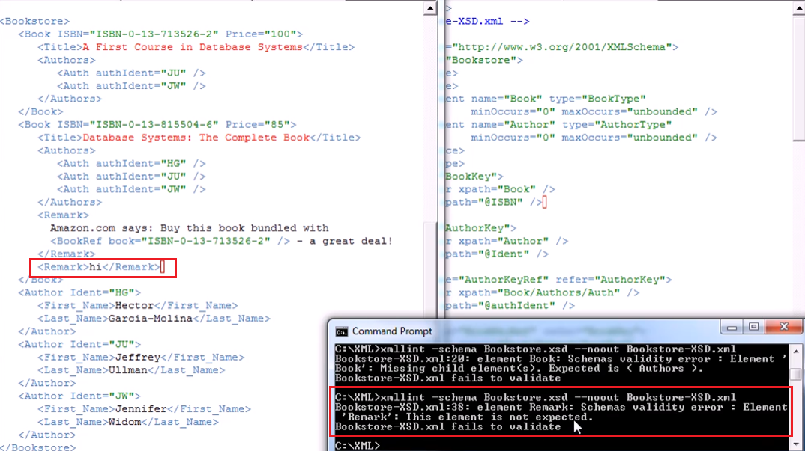

XSD



* maxOccurs defaulted to maxOccurs = 1